IMPORTANT – before you start doing your solution, MUST do the following steps:

- Create your MS SQL database named ContactDB by running code in script
ContactDB.sql.
- Copy given file DBContext.java (2) to source package (src\java) folder under your web project. You might need to use and name a java package for (2), free to set the name of package.
- You MUST use DBContext.java for your all database connection.
- Set the home page/default for your project as AddContact.jsp page.

Questions:

Create a AddContact.jsp page with GUI as below figures (0.5 Point):
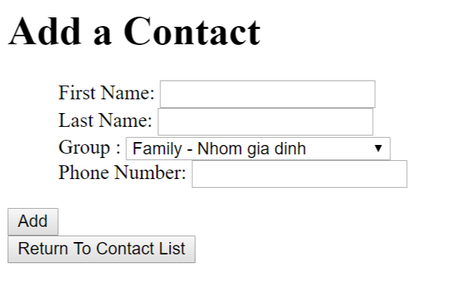

Requirements:
- Value for Phone Number must be numerical (0.25 Point)
When the users click on Save button, validate the data on the input form as rules:
- Require data for all text fields (0.5 Point - 0.25 Point for each error message).
When the validation is correct.

Add information on input form to Contact table (1 Point) and browse to ListContacts.jsp page (0.25 Point).
When users click on the “Return To Contact List” button, browse to ListContacts.jsp page (0.25 Point) which will be shown as below.
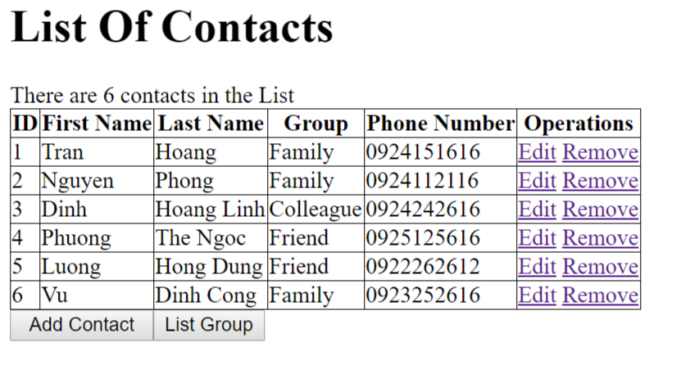
The table must have the same columns with one in above figures.
Requirements:
- Output all Contacts in Contact table to ListContacts.jsp as above table (1 Point).
- Calculate and display the number of Contacts of result (0.25 Point).
- Values for Groups should be corresponding to the Name of Group in Database (0.25 Point).
When users click on button “List Group”, browse to ListGroups.jsp which will output information of all groups (1 Point),
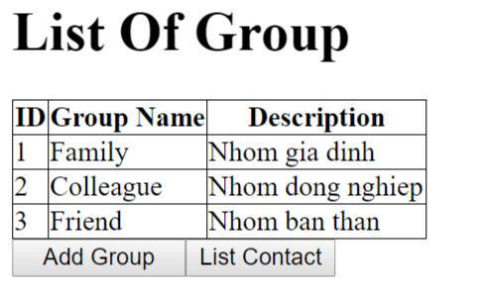

When users click on List Contact, browse to ListContacts.jsp page (0.25 Point).
When users click on Add Group, browse to AddGroup.jsp which will be used to add a new group into the database(0.25 Point)
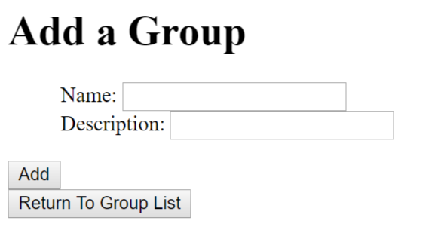
Requirements:
- Add information on input form to Group table (1 Point) and browse to ListGroups.jsp page (0.25 Point).
- When users click on the “Return To Group List” button, browse to ListGroups.jsp page (0.25 Point) which will be shown as below.

On the “Contact List” page, when the users click on the link Remove, the corresponding record will be removed from the database, and the list will be refreshed to reflect the result. (0.25 Point)
When users click on the link Edit, browse to EditContact.jsp page (0.25 Point)
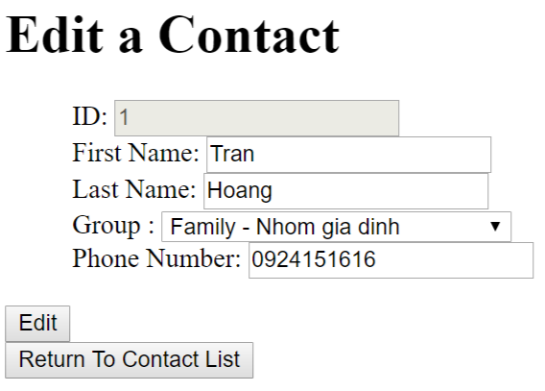
Requirements:
- Value for Phone Number must be numerical (0.25 Point).
- Save the edited information into the database (1 Point)
- When user click on “Return To Contact List”, browse ListContacts.jsp page. (0.25 Point)

